**OB2 Peer Observation Report**

Session to be observed: Paper Prototyping Workshop (09.03.23) - specifically the last hour of a 3 hour workshop focusing on concertina book-making, the third of three different types of book-binding techniques explored in the workshop.

Size of student group: 11 students (though one left as had to attend something else, so the last half of the sessions was 10 students) – estimated mix of international/home/EU, predominantly international

Type of activity: Practical Workshop

Observer: Joel Simpson

Observee: Tilly De Verteuil

**Observations, suggestions and questions**

I’ve separated the below observations/suggestions/questions into themes, in response to your questions from the OB1 form. Although this was a very different kind of session to the ones I facilitate, there were many aspects of the observation that I can learn from and I highlight these below.

1. Gauging student learning

This section responds to the following, mentioned on your OB1 form: ‘I am interested to see if there is a gap in the information that I could better explain, that I am missing due to the tacit nature of the skill. Am I missing signs of student engagement or disengagement?’

1a. How can the layout of the space support student engagement and the communication of tacit knowledge?

There are three moments during the session where you demonstrate different steps in making the book. In these moments, students form a horizontal line behind a long table (fig. 1). The advantage of this is that they all see what you’re doing head-on, and you can see them directly. However, students at the end of the row are quite a distance away from what you’re doing. Though this didn’t appear to hinder the understanding of these students in this instance, it may in others. I wonder if by delivering these demonstrations at the end of a table or on a smaller square table (fig. 2), students can see more clearly, while you can continue to see them more also?

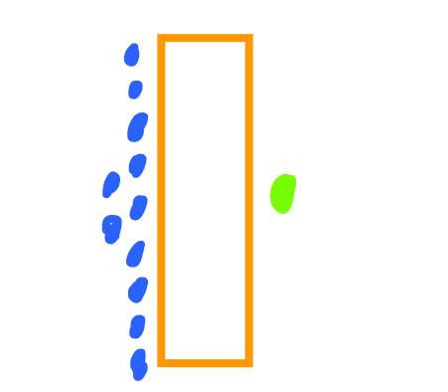< fig. 1 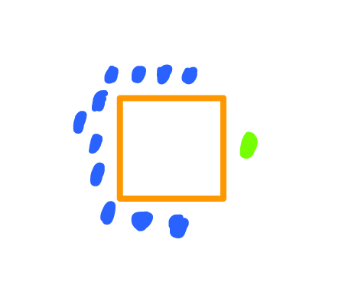< fig. 2

Additionally, sitting somewhere adjacent to the notion of (dis)engagement is the idea of belonging. Although I’m not for a second suggesting students standing further away might have felt in some way *outside,* I’m thinking back to James Corazzo’s [presentation](https://moodle.arts.ac.uk/pluginfile.php/1494137/mod_label/intro/PRES_Part%20of%20the%20Furniture%20UAL.pdf) to the PgCert cohort on 11th Jan, and wondering whether increasing the proximity of the students at the ends of the table may render something akin to engagement, which is *belonging*, in all its conceptual slipperiness?

An additional note regarding the layout was that no student was sat on their own. Do you encourage this at the beginning of the session or was this accidental? Either way, it gave each of the students a partner to speak with in the event that they were stuck.

1b. Are you ‘missing signs of student engagement or disengagement’ and if so, how?

The workshop moved between two states: sections where you were demonstrating the steps, and sections where students were at their desks applying what they had learnt to their own books. In your demos, there was real clarity of language, a helpful tempo and good use of repetition. One particular method chosen to gauge student understanding during the demo sections seemed to be working. This was when, at the end of the demonstrations, you asked students if they understand the steps you had just taken them through, which invited them to nod if they did, and shake their head if they didn’t. This was simple but effective.

In the ‘application’ phases of the workshop, there were two key ways through which students could be supported if they were stuck.

Firstly, whilst providing the students a bit of time (4-5 minutes) with which to apply the learnings from the demo on their own (see section 2a below), you were present at all times at the front of the space, which meant that students who were stuck felt that they could come up and speak with you away from the group.

Secondly, after a short while where students were required to apply the learnings themselves after each demo, you then walked through the space, and perceptively picked up on students who appeared confused but had not asked for help. In one particular instance, with a student at the back table, you noticed where she was going wrong without her asking you, and empathically and slowly offered advice, without laboring your point.

While these two methods of ensuring student engagement absolutely worked for the workshop I observed, would they apply in all situations? Could colored cards/paddles be used for students who felt less capacity to ask you over to their desk / or whose confusion/mistake was less visible than the above instance? While it appeared that your colleague and yourself had normalized the act of coming up to the front if they were stuck, could they have been reminded about this throughout? If this is an important decision for your pedagogic context, could the reason for this method have been unpacked with the students (eg. did it represent an important lesson regarding the need to actively ask for help and not to rely on others to offer guidance?)

2. Learning outcomes

2a. Meeting the learning outcomes

Here I wanted to pick up on whether/how learning outcomes where achieved, but also your focus on your ‘teaching delivery and style’ from the OB1 form. You note that the intention of the session is that students ‘leave understanding the basic techniques needed, and have the tactile skills required to inform the design and creation of their own work outside of the taught session.’

It can certainly be said that all 10/11 students learnt the specific skills related to concertina book-making, which is demonstrated in that they all (predominantly independently) applied what they learnt in the demonstrations to create their own concertina book.

In terms of the students being invited to recognize that the skills they were developing in the session could ‘inform the design and creation of their own work outside of the taught session’, I think this was centrally achieved in two additional ways.

First, your provision of 4 or 5 minutes after the demos, where they would apply their learnings to the task while you occupied yourself with another task, was a brief window where students’ own agency was gently recognised.

Secondly, through your interactions with them, when they were sharing their books with you at the different stages of completion. In these instances, your language was always affirmative, using words such as ‘beautiful’ and ‘really nice' when students had produced something similar to the prototype, but also growth mindset language in moments where they were stuck. Sabri (2017) has [noted](https://ualresearchonline.arts.ac.uk/id/eprint/14370/1/year%204%20report%20-%20%20final.pdf) how micro-affirmations can be vital for students particularly from ethnic minority backgrounds in learning contexts where they might feel misrecognised/excluded. Given these affirmative interactions, the session emphasized that I should encourage my students - many of whom don’t use, or underuse, the workshop spaces at Chelsea – to seek out sessions such as this, especially as material learning can subvert the apparent power that other forms of learning might unfairly wield, and where staff biases can be more present.

2b. Recognizing/expanding more subtle learning outcomes

Whilst noting the above, I think there are additional things that are being learnt in the space which are not included in your statement re. LOs. Below I briefly describe how you’re delivering these more subtle learning outcomes as well as how to possibly lean into these, in order to facilitate additional opportunities for learning. (The below was also helpful for myself in understanding how to meet my students’ learning outcomes but also my interest in what is counted as a learning outcome and what isn’t).

It was clear that, although the construction of the book might be said to be proof enough of learning, it was through the sharing of their books with you that students could recognize the wider value of their skills. This speaks to the Hardie (2015) [piece](https://s3.eu-west-2.amazonaws.com/assets.creode.advancehe-document-manager/documents/hea/private/kirsten_hardie_final_1568037367.pdf) we explored earlier in the term, which looks at different modes of object-based learning. While all the students are producing the same object in a very similar way (with slight variations), your affirmation provides a ‘wow’ moment for them in which ‘learners are invited to consider the impact that designs can have’ (p. 5). While they’re encouraged in this interaction to learn through the *presentation* of objects (as well as the production of them), could this subtle encouragement be made more explicit? For example, could you unpack with students what they hope to do with the books they’ve made, where they might place them (given what you mention at the beginning about the concertina book as a display item), and what others might learn from these objects?

There was also a consistent, though quite implicit, emphasis on the quality of objects for usage, which is arguably acknowledged in your learning outcome, but may benefit from being unpacked in more depth. I noted your employment of metaphor (“easier to walk through the trees...”) when describing why you were advising the students to make certain decisions in the production process. This was helpful in framing the tips you were offering. Though you facilitated some participation to open this conversation up (“why would I paint my glue in this direction?”), could there have been more opportunities during the demonstrations to ask students why they might be recommended certain materials/processes? Might this have justified and/or challenged the aspiration towards “neatness” by inviting greater exploration of why the quality of objects is important? Might this have also underlined the inherent need for problem-solving (or embracing “failure”) within the making process (another currently subtle learning outcome)?

3. Structure

Finally, you mentioned in your OB1 that you were interested in whether the flow of the session was working, whilst adding that ‘there is a portion of the workshop that often takes a long while to get through, resulting in us running overtime. I am interested to see if this is an issue with student attention, or if I can mitigate this more in the structure of the teaching.’ I noted the following time stamps.

12.00 - 12.16: First demo and student activity

12.16 - 12.31: Second demo

12.31 - 12.52: Second student activity

From 12.52 it was a little bit of a rush to end their book-making task, and there were 5 students still going at 13.05. In answer to your above question, there are a few possibilities for wrapping up the session within the time frame. I note that they all nearly finished this section of the first folding section task earlier than when you called them back - could the 12.00 - 12.16 section be shorter by students folding their concertina shape during the demo? Or is it a matter of shortening earlier sections of the workshop (where the two other book-making techniques are explored) to allow more time for the concertina section?

**Reflection on the observer’s comments and ideas to follow up:**

Receiving a thorough observation of a recently developed practical workshop is incredibly useful, especially as we are currently undergoing a significant physical change to our workshop space. With the redesign of the layout, we can consider the flexibility of different demonstration styles. It's an interesting point you raise about the connection between proximity and a sense of belonging in a learning environment, as per James Corazzo’s presentation. I have noticed in larger groups it is possible that students seated further away from the centre of the action can feel less connected to the class and more hesitant to participate. Exploring different seating arrangements and teaching techniques, such as teaching in the round as you suggested, could certainly help create a more inclusive and engaging learning experience for all students. It's worth experimenting with different approaches to see what works best across our varied workshops.

I am glad it was noticed that no student was alone. To encourage a sense of community, I often suggest that students spread out in the space and share tables. However, I'm careful not to push anyone into uncomfortable situations and typically suggest pairs of friends move over to make the best use of the space.  
  
It's also encouraging that this session highlighted the importance of encouraging students to attend workshops and other learning opportunities, especially those who may not usually use these spaces. Material learning can provide a level playing field where biases are less present, and can help to subvert the power dynamics that may exist in other forms of learning.

The idea of exploring ways to adjust the timing of the workshop to ensure that all students have enough time to complete the book-making task is a good one. Shortening earlier sections of the workshop to allow more time for the concertina section could work. I will discuss these options with my co-facilitator to see what adjustments can be made to the workshop to ensure that all students have enough time to complete the task within the given time frame. It would be interesting then, to follow this up with opportunities for students to rate and evaluate their levels of engagement, seating arrangements, environment and overall experience. Thank you for your insightful comments, and for taking the time to engage with my teaching.